Secure software coursework 1

## UML DIAGRAM

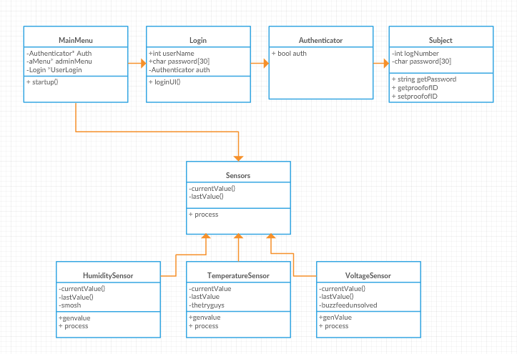

Above is my UML Class Design Diagram. I decided to use this diagram as it clearly maps out the structure of a system by modelling its classes, attributes, operations, and relationships between objects. It was useful in designing the program in the first place and just as useful afterwards.

## Sensor Data Simulation

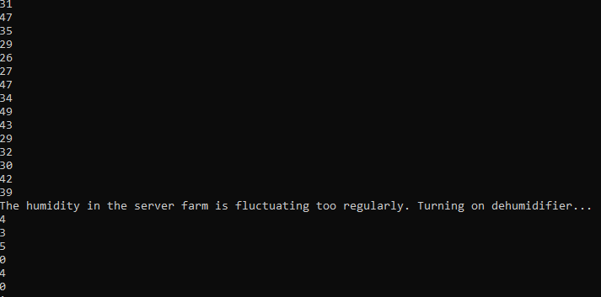2

All three of my sensors generate genuinely reasonable data that could be seen as realistic.

## Processing of Sensor dAta

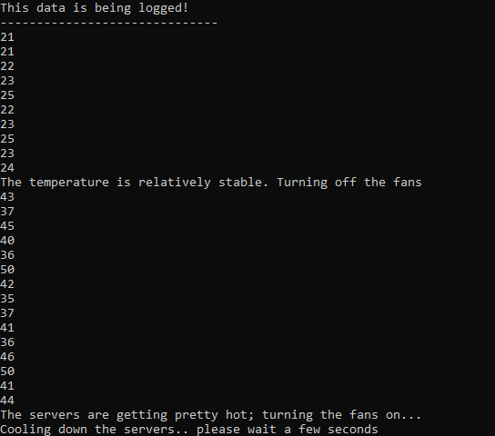

The processing of the sensor data comes in the form of the turning on an off of the hardware that the program controls. E.g. if the temperature gets too warm, the fans will turn on.

## Persistent Storage



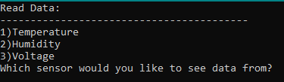

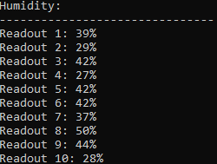



Within my program, you can safely log your sensor outputs into a txt file and then if you choose you can read data within the program using the “Read Data” option in the Admin Menu.

## Interface

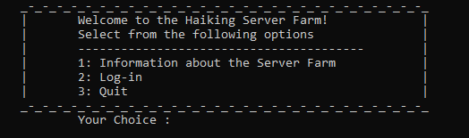

1

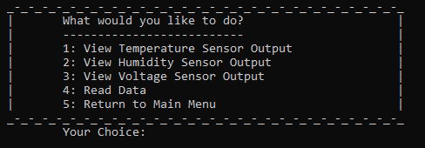

I believe that my user interface is well presented and reasonably professional. It is good-looking as well as functional

## Secure design principles i

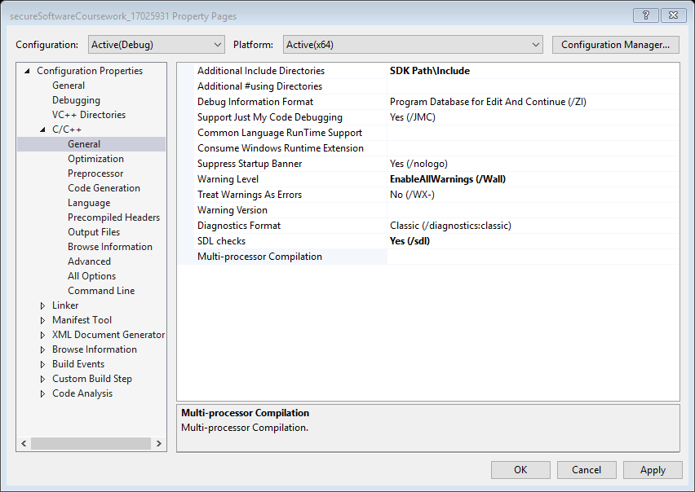



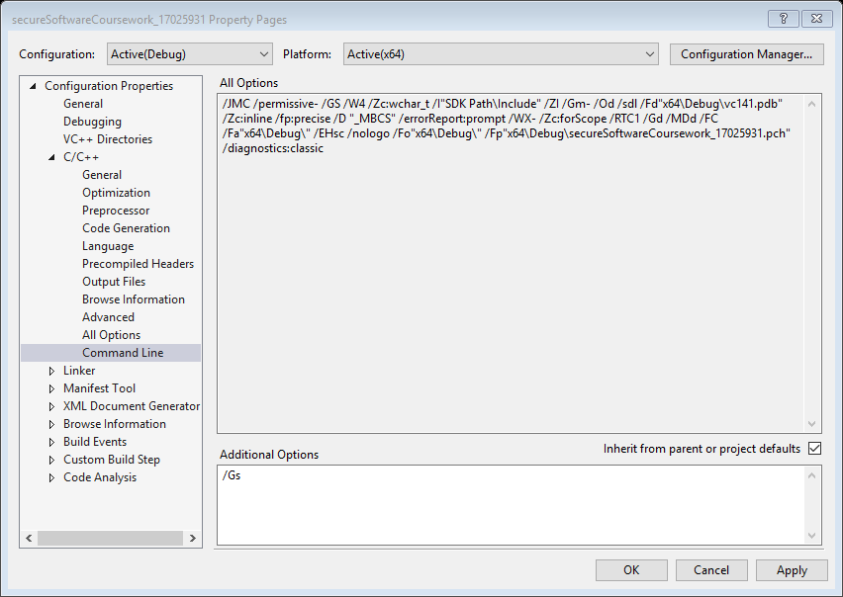

I have used all the secure design principles outlined in the marking scheme using compiler flags.

## Secure design principles ii

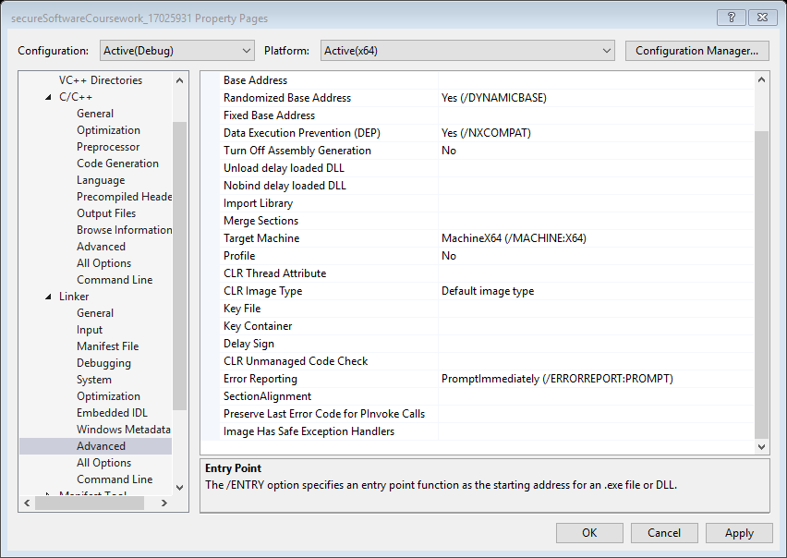

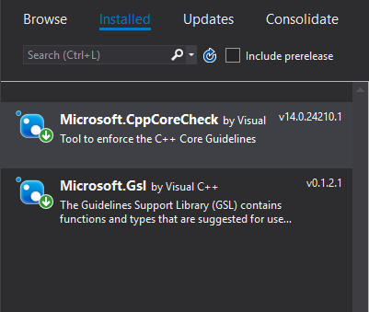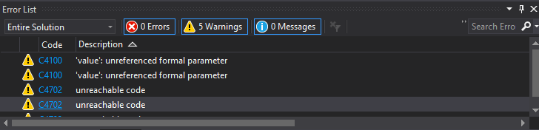

I have used all the secure design principles outlined in the marking scheme using linker flags.

## Secure pattern i

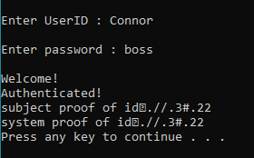

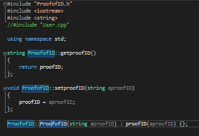

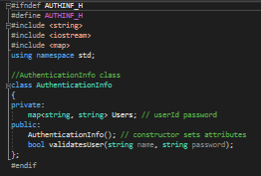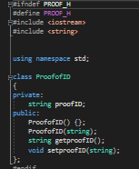

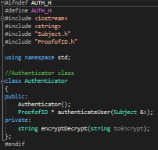

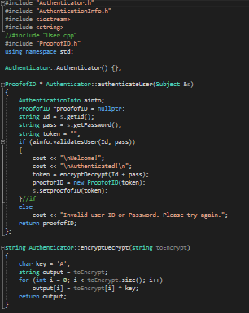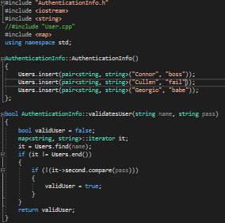

For my first Secure Pattern, I chose to use the Authentication Pattern. This works exactly as I intended to and outputs an new unique proofofID.

## Secure pattern ii



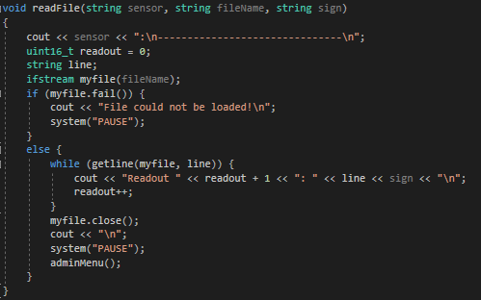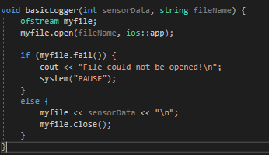

My second Secure Pattern was a Secure Logger. In every sensor you get the option to log the sensor output. If you choose to do this your sensor data will be safely stored into a text file and you can read it either separately or within the program.